**DITES Documentation**

**Company Profile**

Young technology enthusiasts who founded our organization, DITES (Development Institute of Technical Education and Skill), feel that there aren't enough opportunities in early school to prepare for a career in IT. Our objective is to give high school students who are eager to get a head start on learning about the technology that benefits us all in our everyday lives an early education. We are aware that early learning centers don't provide these youngsters enough options, and we hope to fill that gap. In order for these students to thrive in their further studies and have rewarding employment, we would like to provide them with the necessary information and skills in these subjects.

**Organizational Structure**

We have a very simplistic structure for our organization, the students and teachers are part of the academic branch which is run by the department head. On the Administration side we have an IT, HR, Marketing, Finance and Utilities department which all are in charge of their respective areas. Both of these branches are overseen by the Principal and Secretary

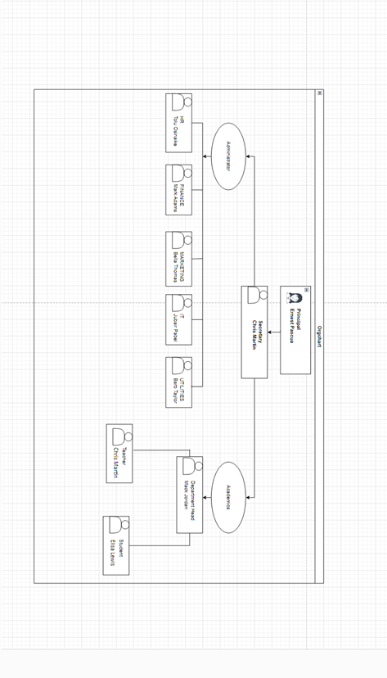**Logical Topology**

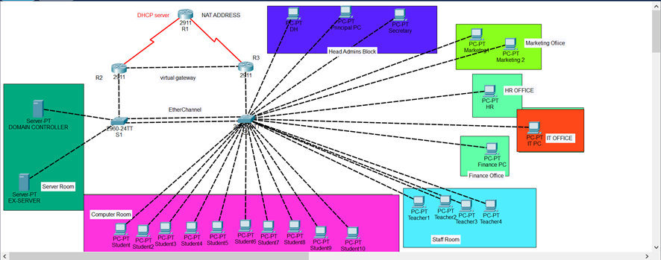

The Logical Topology shows the school network with segmented and its segmented VLANs. The switches are connected via an Ethernet port channel “P01” and are trunked to send information to each other. Routers R2 and R3 are linked through HSRP. Inter-VLAN routing is configured so each segment can talk to one another. In a full production system, we would have WLANs would have been enabled to accommodate more devices but the topology shows a fixed set of devices.

The school system server is going to have a fully containerized mail system meaning mail addresses with the school domain name would not be able to reach the outside network. ACL’s will be configured to restrict pings to the server, but the server would be allowed to ping out. R1 would have a dynamic NAT with overload so all devices in the network would be able to reach the outside networks from the public address.

The Interface and VLAN configuration information can be found in the tables below. All networks have been implemented on packet tracer.

**IP Address Design and Planning**

**IP Addressing Scheme**

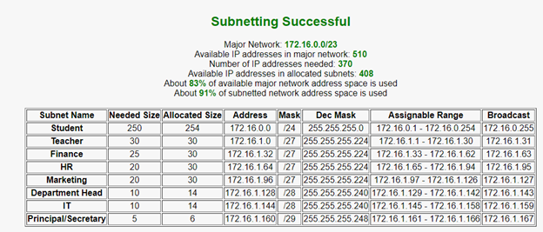

**VLAN Table & Address Ranges**

|  |  |  |  |
| --- | --- | --- | --- |
| **NAME** | | **VLAN** | |
| **Student** | | **2** | |
| **Teacher** | | **3** | |
| **Finance** | | **4** | |
| **HR** | | **5** | |
| **Department Head** | | **6** | |
| **Marketing** | | **7** | |
| **IT** | | **8** | |
| **Principal** | | **9** | |
| **Servers** | | **10** | |
| **Native** | | **99** | |
| **Management** | | **20** | |
| **VLAN** | | **Network ADD** | | **R3 ADDRESS** | | **R2ADDRESS** | **VIRTUAL ADDRESS** | **IP RANGE**  **START** | **IP RANGE**  **FINISH** | **Subnet** |
| **STUDENT (2)** | | **172.16.0.0** | | **172.16.0.1** | | **172.16.0.2** | **172.16.0.3** | **172.16.0.4** | **172.16.0.254** | **.0** |
| **Teacher (3)** | | **172.16.1.0** | | **172.16.1.1** | | **172.16.1.2** | **172.16.1.3** | **172.16.1.4** | **172.16.1.30** | **.224** |
| **Finance (4)** | | **172.16.1.32** | | **172.16.1.33** | | **172.16.1.34** | **172.16.1.35** | **172.16.1.36** | **172.16.1.62** | **.224** |
| **HR (5)** | | **172.16.1.64** | | **172.16.1.65** | | **172.16.1.66** | **172.16.1.67** | **172.16.1.68** | **172.16.1.94** | **.224** |
| **DepartmentHead (6)** | | **172.16.1.96** | | **172.16.1.97** | | **172.16.1.98** | **172.16.1.99** | **172.16.1.100** | **172.16.1.126** | **.224** |
| **Marketing (7)** | | **172.16.1.128** | | **172.16.1.129** | | **172.16.1.130** | **172.16.1.131** | **172.16.1.132** | **172.16.1.142** | **.240** |
| **IT (8)** | | **172.16.1.144** | | **172.16.1.145** | | **172.16.1.146** | **172.16.1.147** | **172.16.1.148** | **172.16.1.158** | **.240** |
| **Principal/Secretary (9)** | | **172.16.1.160** | | **172.16.1.161** | | **172.16.1.162** | **172.16.1.163** | **172.16.1.164** | **172.16.1.166** | **.248** |
| **SERVER (10)** | | **172.16.1.168** | | **172.16.1.169** | | **172.16.1.170** | **172.16.1.171** | **172.16.1.172** | **172.16.1.174** | **.248** |
| **R1 and R2** | | **172.16.1.176** | |  | |  |  | **172.16.1.177** | **172.16.1.178** | **.252** |
| **R1 and R3** | | **172.16.1.180** | |  | |  |  | **172.16.1.181** | **172.16.1.182** | **.252** |
| **R2 and R3** | | **172.16.1.184** | |  | |  |  | **172.16.1.185** | **172.16.1.186** | **.252** |

**Connection Information**

|  |  |  |  |
| --- | --- | --- | --- |
| **Device** | **Interface(s)** | **Vlan** | **Connection** |
| S2 | F0/15-24 | Student | N/A |
|  | F0/11 - 14 | Teacher | N/A |
|  | F0/9 - 10 | Finance | N/A |
|  | F0/3 | Department Head | N/A |
|  | F0/4 | Principal | N/A |
|  | F0/6 - 7 | Marketing | N/A |
|  | F0/10 | IT | N/A |
|  | F0/5 | Secretary | N/A |
|  | F0/8 | HR | N/A |
|  | F0/1 - 2 | N/A | S1 |
| S1 | G0/1 | N/A | R2 |
|  | F0/1 - 2 | N/A | S2 |
| R1 | S0/1/0 | N/A | R2 |
|  | S0/1/1 | N/A | R3 |
| R2 | S0/2/0 | N/A | R1 |
|  | G0/0 | N/A | R3 |
| R3 | S0/1/0 | N/A | R1 |
|  | G0/0 | N/A | R2 |

**Addressing Table**

|  |  |  |  |  |  |  |
| --- | --- | --- | --- | --- | --- | --- |
| **Devices** | **Interface** | **IP address** | **Subnet** | **Default Gateway** | **VIrtual Address** | **Vlan** |
| **R1** | **S0** | **172.16.1.177** | **255.255.255.252** | **N/A** | **N/A** |  |
|  | **S1** | **172.16.1.181** | **255.255.255.252** | **N/A** | **N/A** |  |
|  |  |  |  |  |  |  |
| **R2** | **S0** | **172.16.1.178** | **255.255.255.252** | **N/A** | **N/A** |  |
|  | **G0/0** | **172.16.1.185** | **255.255.255.252** | **N/A** | **N/A** |  |
|  | **G0/1.2** | **172.16.0.2** | **255.255.255.0** | **N/A** | **172.16.0.3** | **Vlan 2** |
|  | **G0/1.3** | **172.16.1.2** | **255.255.255.224** | **N/A** | **172.16.1.3** | **Vlan 3** |
|  | **G0/1.4** | **172.16.1.34** | **255.255.255.224** | **N/A** | **172.16.1.35** | **Vlan 4** |
|  | **G0/1.5** | **172.16.1.66** | **255.255.255.224** | **N/A** | **172.16.1.67** | **Vlan 5** |
|  | **G0/1.6** | **172.16.1.98** | **255.255.255.224** | **N/A** | **172.16.1.98** | **Vlan 6** |
|  | **G0/1.7** | **172.16.1.130** | **255.255.255.240** | **N/A** | **172.16.1.131** | **Vlan 7** |
|  | **G0/1.8** | **172.16.1.146** | **255.255.255.240** | **N/A** | **172.16.1.147** | **Vlan 8** |
|  | **G0/1.9** | **172.16.1.162** | **255.255.255.248** | **N/A** | **172.16.1.163** | **Vlan 9** |
|  | **G0/1.10** | **172.16.1.170** | **255.255.255.248** | **N/A** | **172.16.1.171** | **Vlan 10** |
|  | **G0/1.99** | **N/A** |  |  | **172.16.1.99** | **Vlan Native** |
|  |  |  |  |  |  |  |
| **R3** | **S0** | **172.16.1.182** | **255.255.255.252** | **N/A** | **N/A** |  |
|  | **G0/0** | **172.16.1.186** | **255.255.255.252** | **N/A** | **N/A** |  |
|  | **G0/1.2** | **172.16.0.1** | **255.255.255.0** | **N/A** | **172.16.0.3** | **Vlan 2** |
|  | **G0/1.3** | **172.16.1.1** | **255.255.255.224** | **N/A** | **172.16.1.3** | **Vlan 3** |
|  | **G0/1.4** | **172.16.1.33** | **255.255.255.224** | **N/A** | **172.16.1.35** | **Vlan 4** |
|  | **G0/1.5** | **172.16.1.65** | **255.255.255.224** | **N/A** | **172.16.1.67** | **Vlan 5** |
|  | **G0/1.6** | **172.16.1.97** | **255.255.255.224** | **N/A** | **172.16.1.98** | **Vlan 6** |
|  | **G0/1.7** | **172.16.1.129** | **255.255.255.240** | **N/A** | **172.16.1.131** | **Vlan 7** |
|  | **G0/1.8** | **172.16.1.145** | **255.255.255.240** | **N/A** | **172.16.1.147** | **Vlan 8** |
|  | **G0/1.9** | **172.16.1.161** | **255.255.255.248** | **N/A** | **172.16.1.163** | **Vlan 9** |
|  | **G0/1.10** | **172.16.1.169** | **255.255.255.248** | **N/A** | **172.16.1.171** | **Vlan 10** |
|  | **G0/1.99** | **N/A** |  |  | **172.16.1.99** | **Vlan Native** |
| **S1** | **Vlan 10** | **N/A** | **N/A** | **N/A** | **N/A** |  |
| **S2** | **Vlan 10** | **N/A** | **N/A** | **N/A** | **N/A** |  |
| **DC** | **NIC** | **172.16.1.172** | **255.255.255.248** | **172.16.1.171** | **172.16.1.171** | **Vlan 10** |
| **EX** | **NIC** | **172.16.1.174** | **255.255.255.248** | **172.16.1.171** | **N/A** | **Vlan 10** |
| **Test StudentPC** | **NIC** | **DHCP** | **DHCP** | **DHCP** | **DHCP** | **Vlan 2** |
| **Test TeacherPC** | **NIC** | **DHCP** | **DHCP** | **DHCP** | **DHCP** | **Vlan 3** |

**Description and Supporting Screenshots**

**Networking**

Disable DNS lookup:

When DNS lookup is enabled on a router, it can potentially cause a security risk. Also when a router tries to resolve domain names using DNS, it can cause a delay in processing commands. That’s why we disabled the dns lookup on R1,R2,R3, S1,S2.

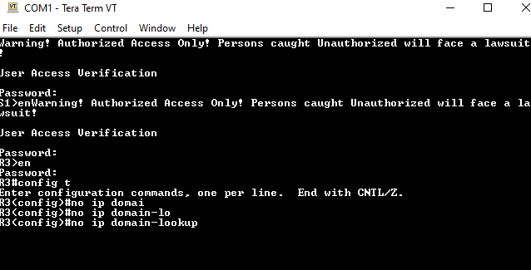

Set hostname:

Host names are set to each and every devices in networking.



Domain name:

Set the domain name to dites.ca for all the devices.

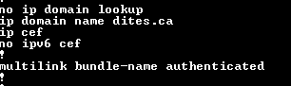

Encrypted Privileged EXEC and line console password :

We set the pass for Privileged EXEC and line console as Dites01@@## and Dites01@###

We also set the minimum length to 10 characters.

Username name with encrypted password:

Gave a usename and password



MOTD banner;

Posted a banner for the message of the day.



Set vty lines 0 4 to use local database and accept ssh:

By configuring VTY lines to use the local database for authentication, we can control who has access to the router by setting up usernames and passwords in the local database. SSH provides encryption of data between the router and the client, making it difficult for anyone to eavesdrop on the session and potentially steal sensitive information such as passwords.

We did it on all the networking devices.

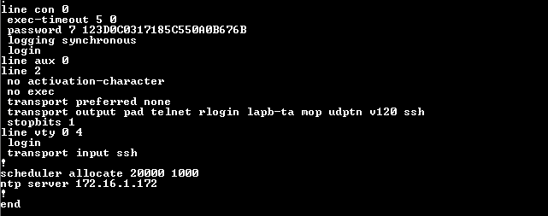

Encypted clear text passwords:

Used the command service password encryption on all the networking devices to to encrypt passwords stored in the configuration file.



Configured int g0/1 and sub-interfaces for R3 and R2:

To do the router on a stick, we configured the interfaces and sub interfaces on R2 and R3. Also did the encapsulation for the vlans.

R3:

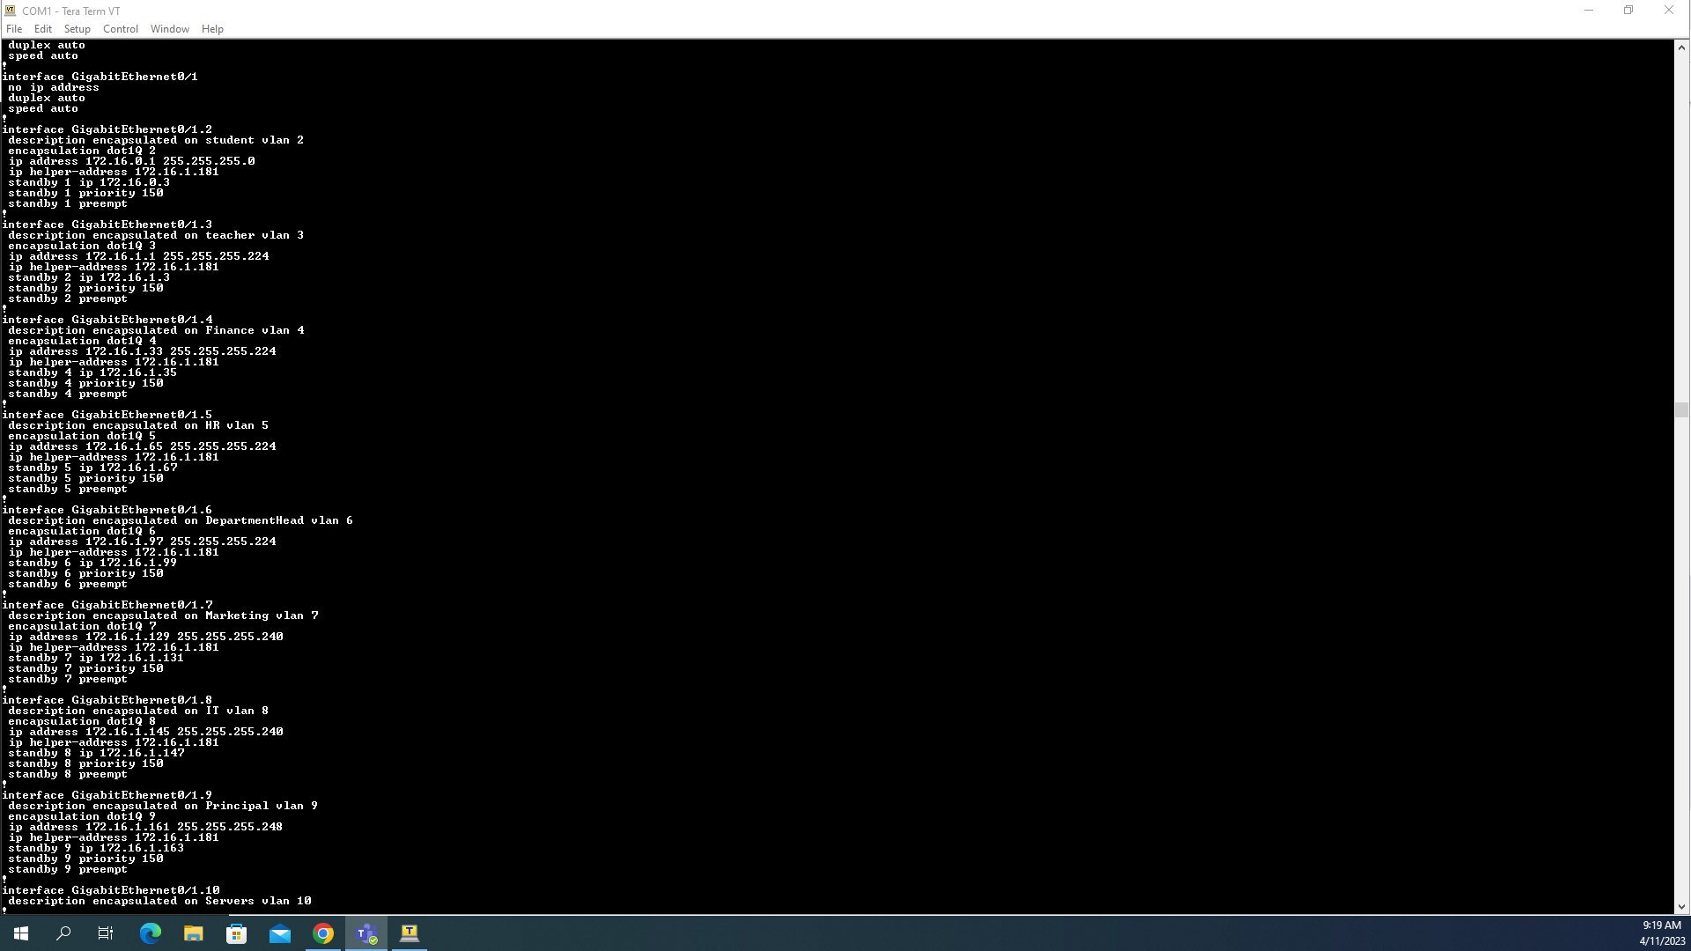

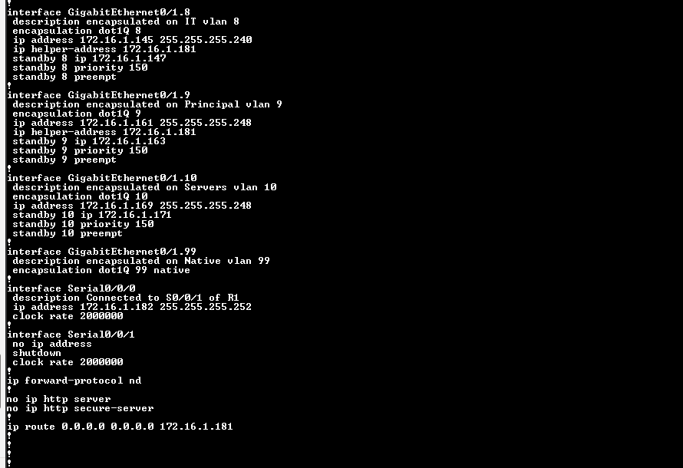

R2:

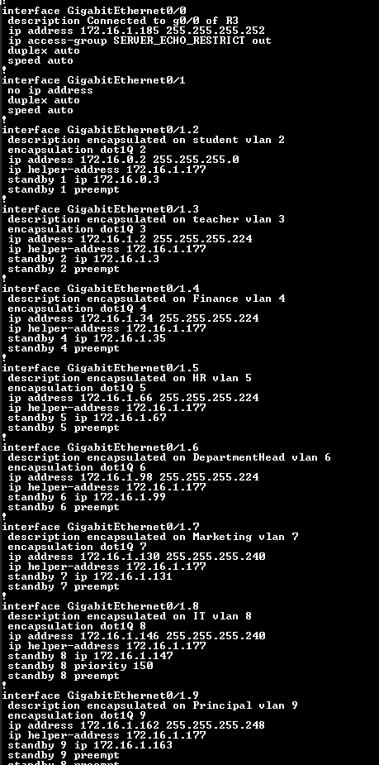

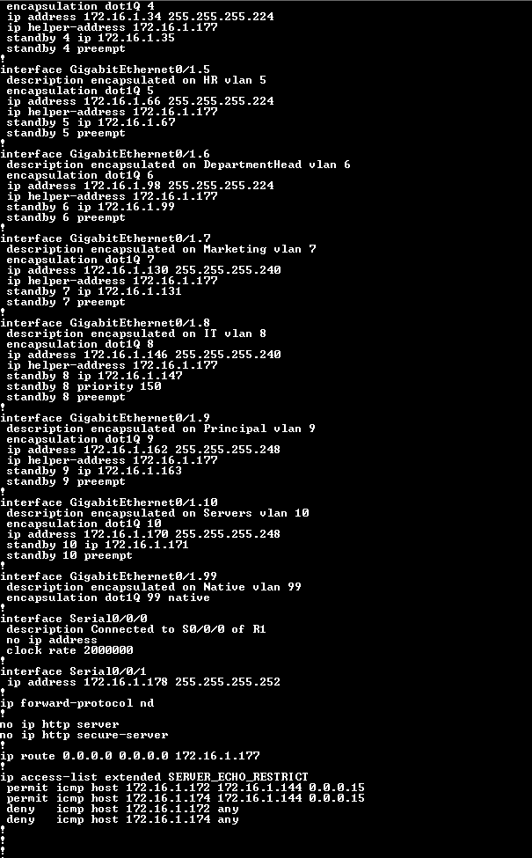

Generating Crypto keys for R3,R2,R1:

Generating a crypto key enables encrypted communication between network devices. The crypto key is used in conjunction with a digital certificate to authenticate the identity of the device

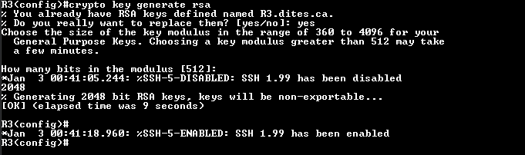

Configured virtual address and stand by priority for R2 and R2:

We are using a backup router R2 and set the priority R3 high We put priotity 150 for R3 and Set the R2 to default. So that if one fails, other one can handle the system. .

R3:

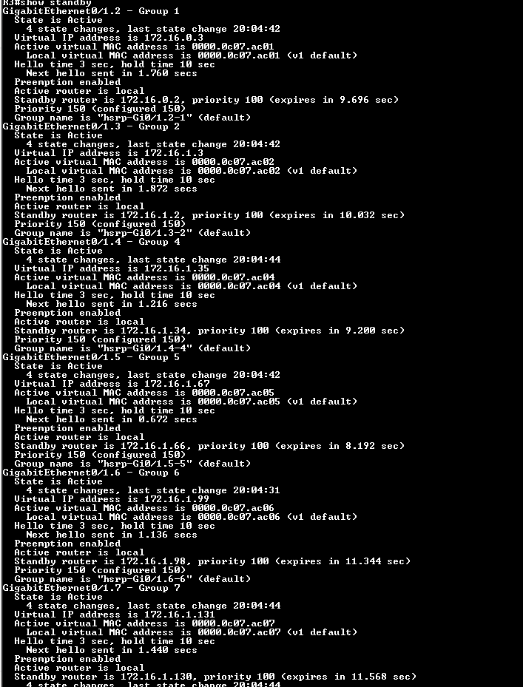

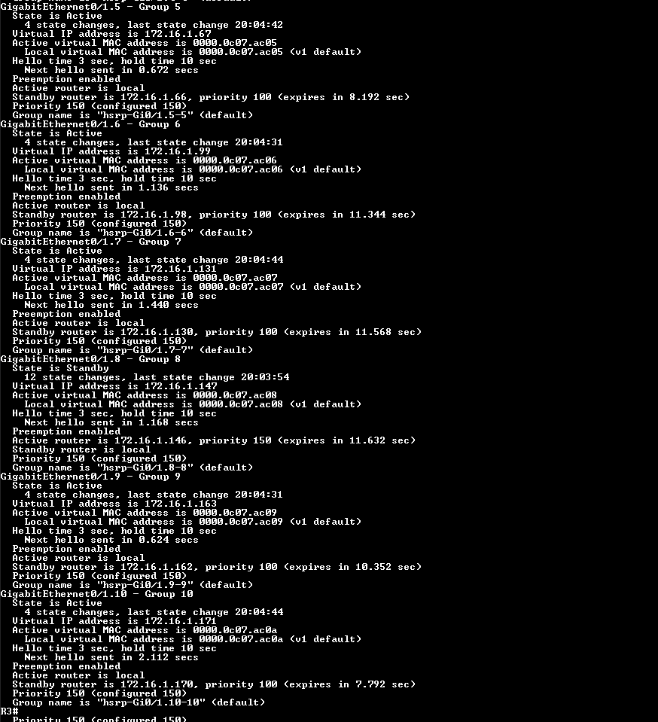

R2:

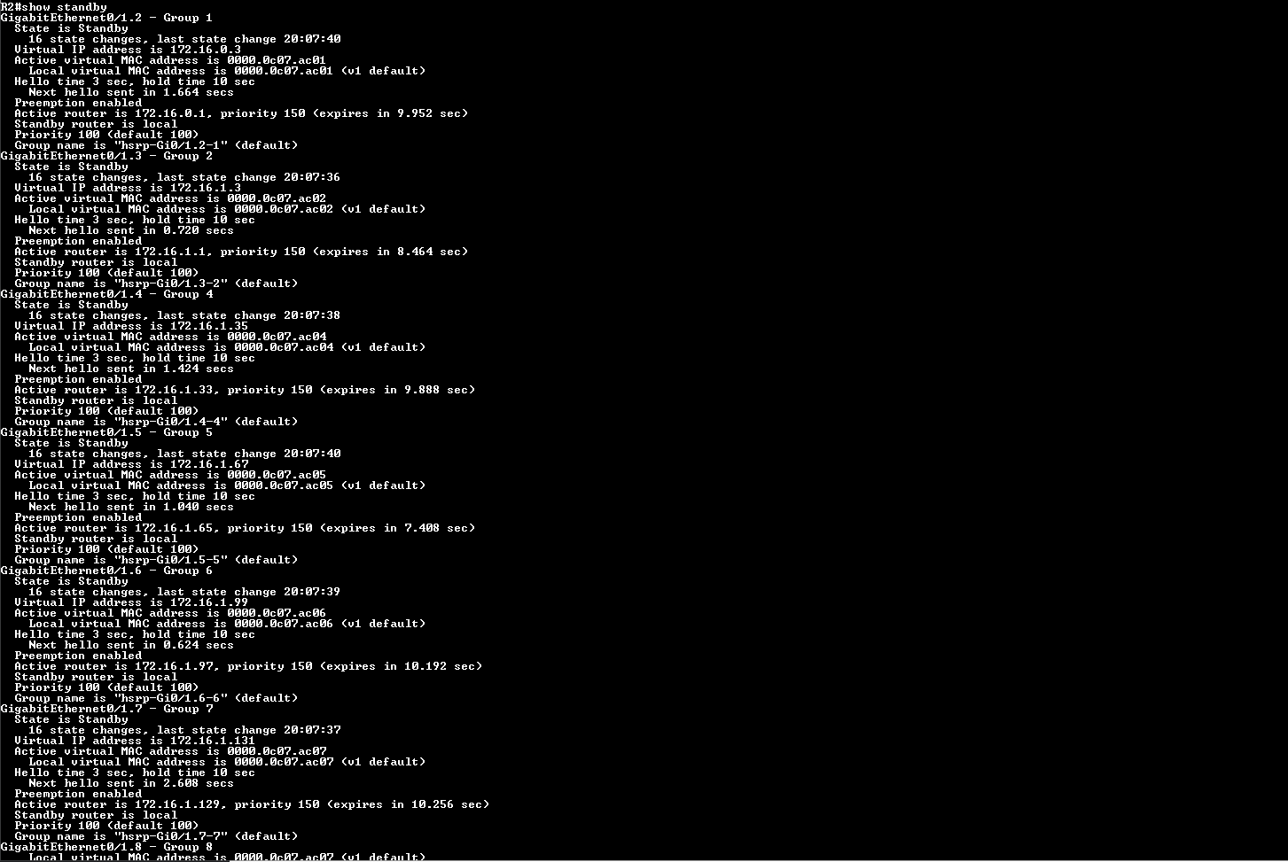

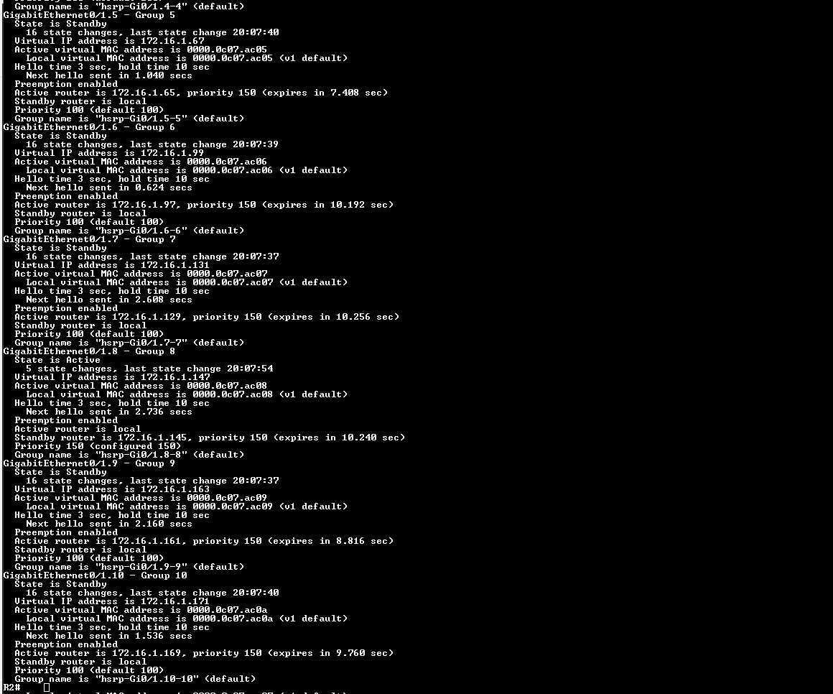

Configure vlans for S1 and S2:

We set the names for the vlans on both s1 and s2 , attached the interfaces with the vlans and shut down the unused ports as needed.

S1:

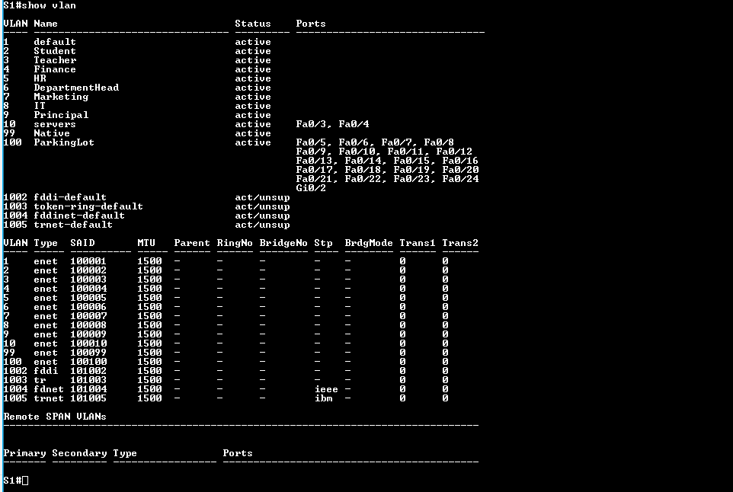

S2:

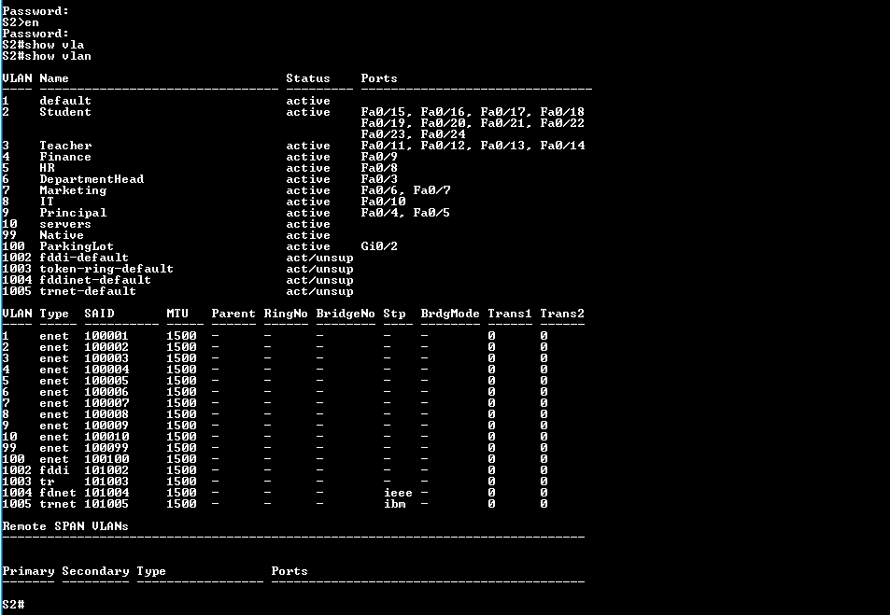

EtherChannel between S1 ans S2:

We did etherchannel between S1 and S2 for Increased bandwidth, Load balancing, Redundancy. We used lacp protocol

S2:

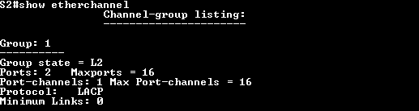

S1:

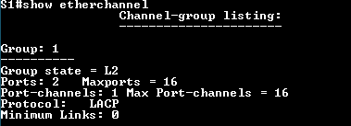

Trunking on S1 and S2:

We did trunking on s1 and s2 for Efficient use of network resources, Simplified network configuration , Improved network performance, Flexibility.

S1;

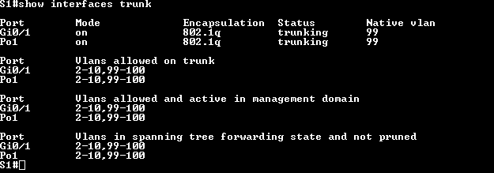

S2:

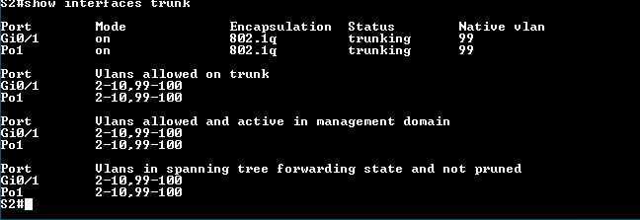

Disabled cdp and lldp on the devices :

We did no cdp and no lldp on all of the devices for networking.

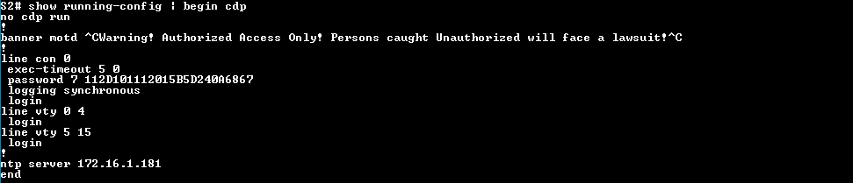



Set port Security on the switches:

We configured max mac address to 5 , violation restrict , and also we put sticky mac address and aslo enabled dhcp snooping trust on the switches.

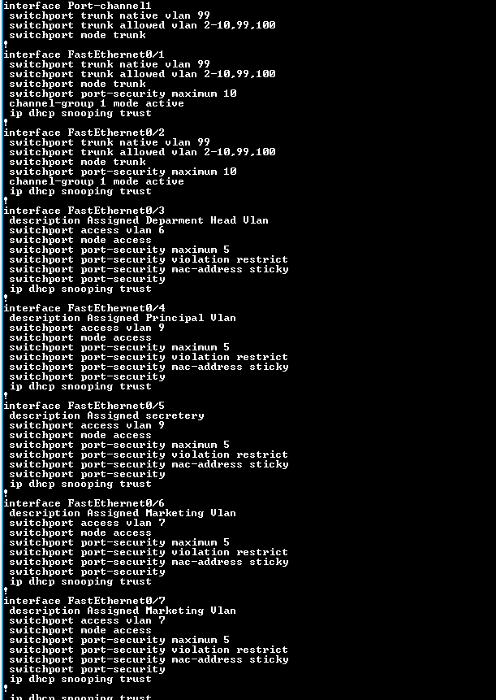

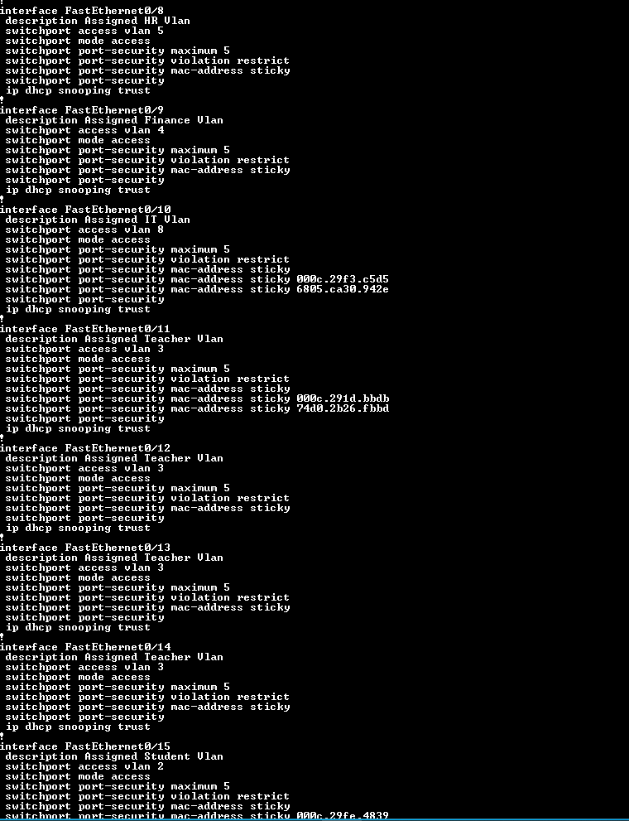

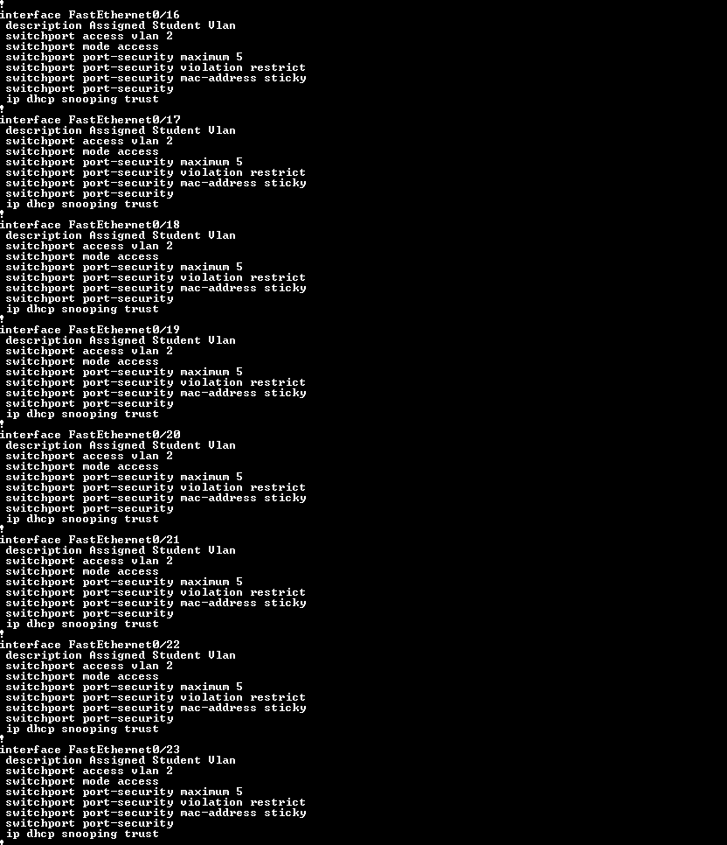

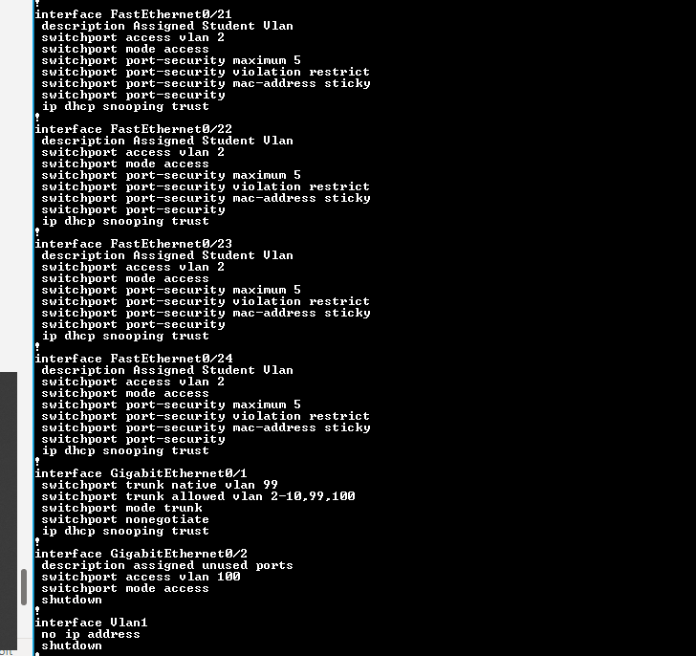

Block failed attempts on login:

Set block mode for failed login on all devices.



Dhcp pools and excluded address for R1:

Configured *the pools for dhcp on r1 and excluded the addresses which are already assinged .*

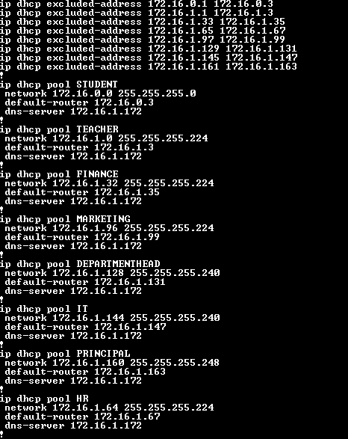

Dhcp relay on r2 and r3:

We et dhcp relay on r2 and r3 for dhcp pools from R1.

R2:

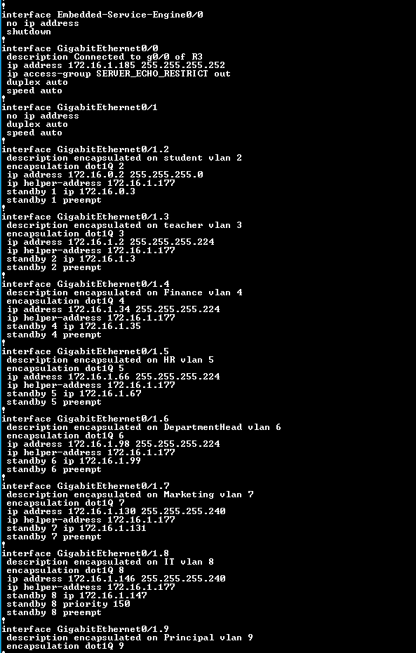

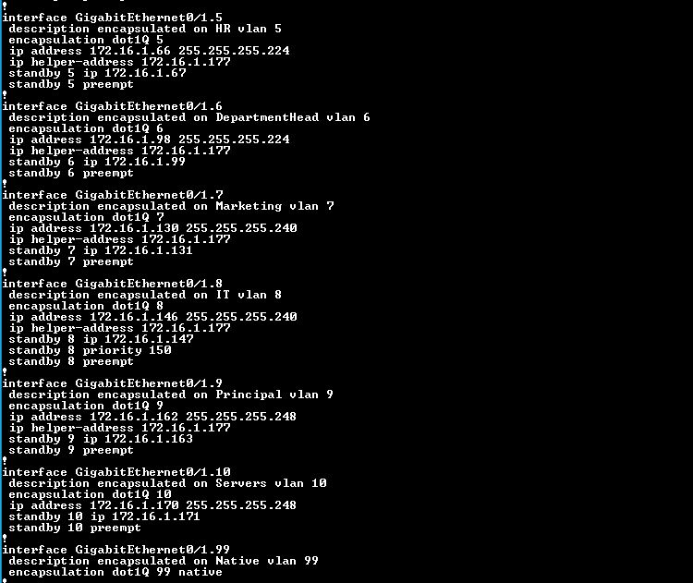

R3:

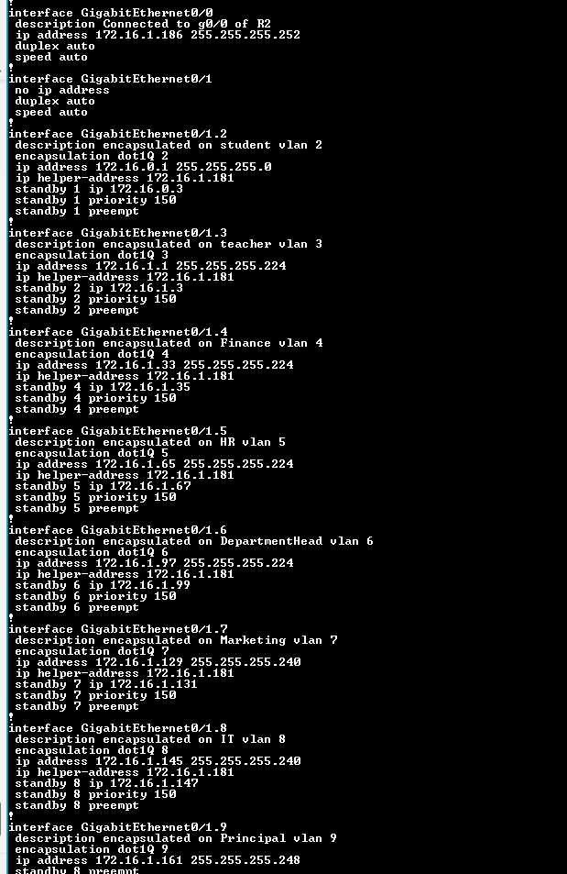

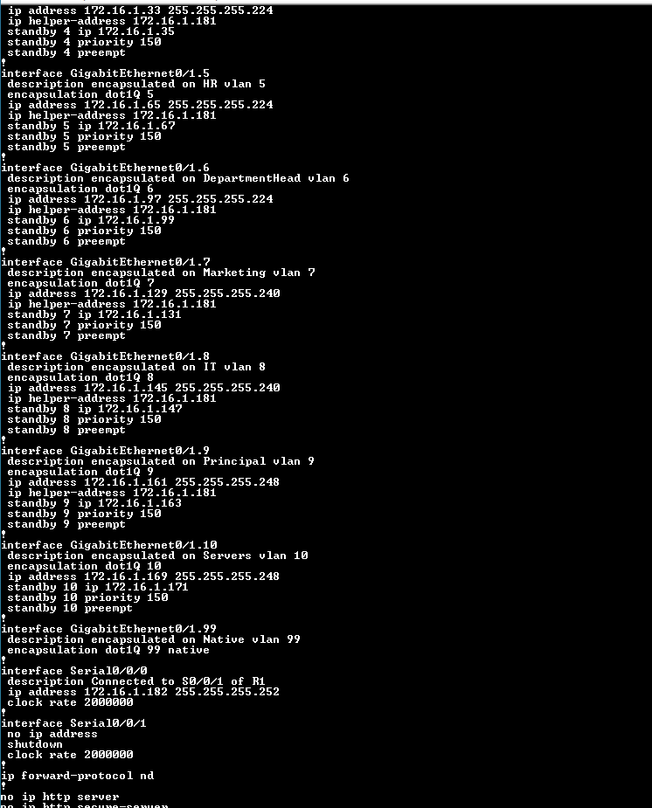

Configured Nat on R1:

Did nat on R1



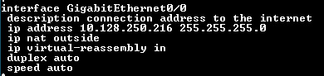

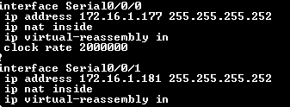



Routes to R2 and R3 from R1:

Set route to r2 and r3

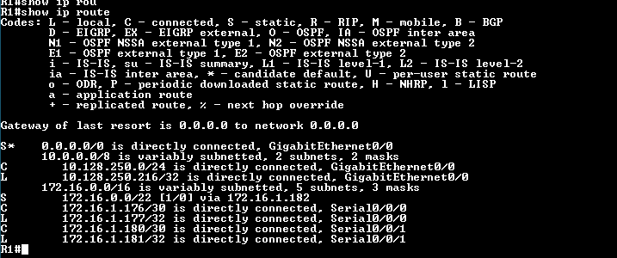

Also routes from R2:

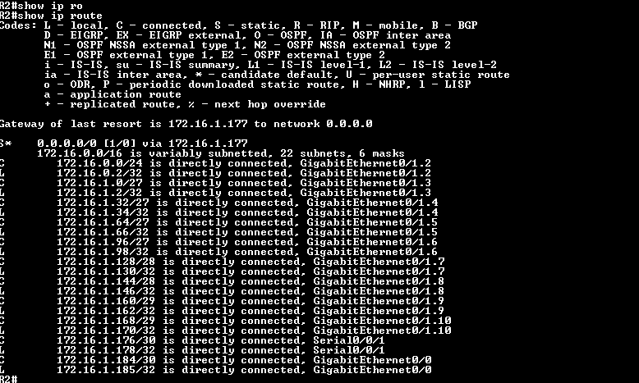

Routes from r3:

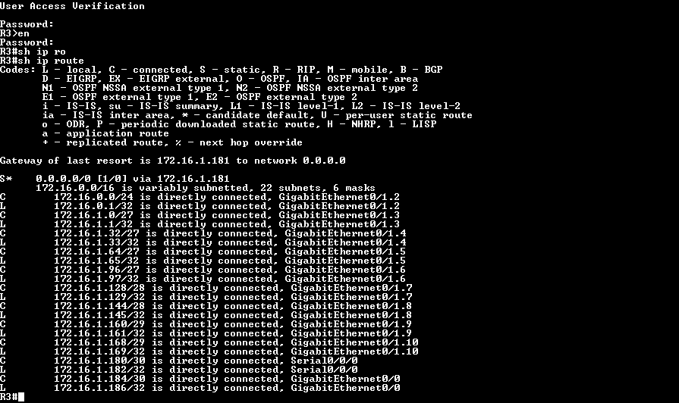

Creating vmnet0 for connecting the network to the vms:

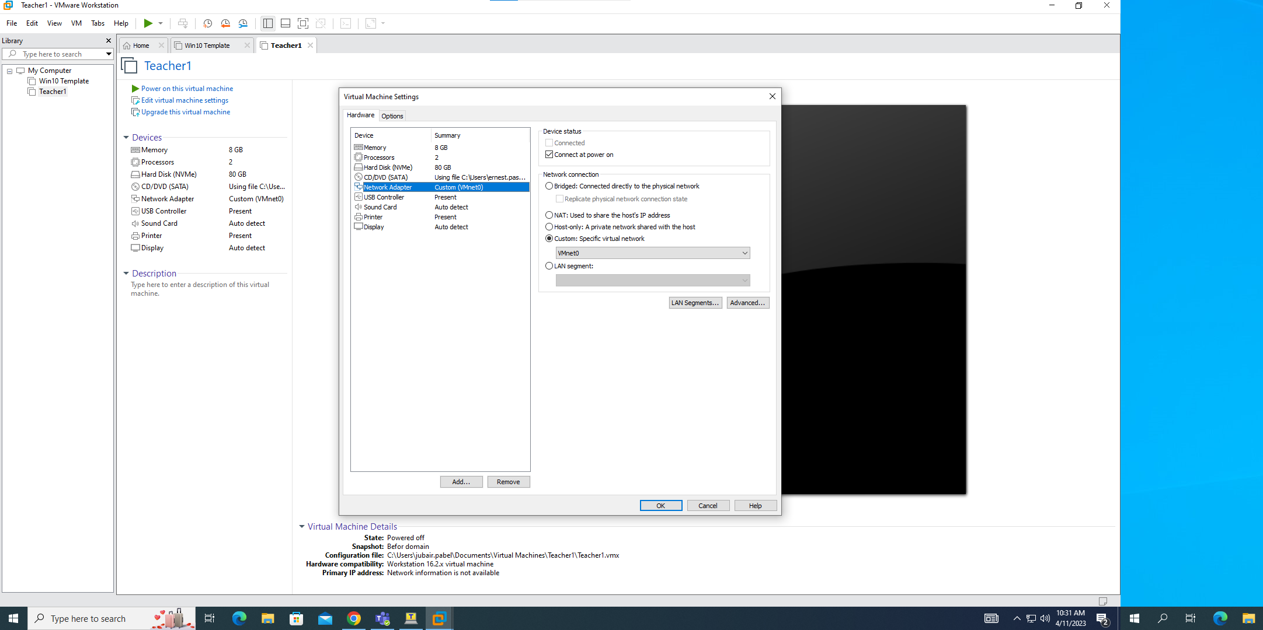

**Exchange Server**

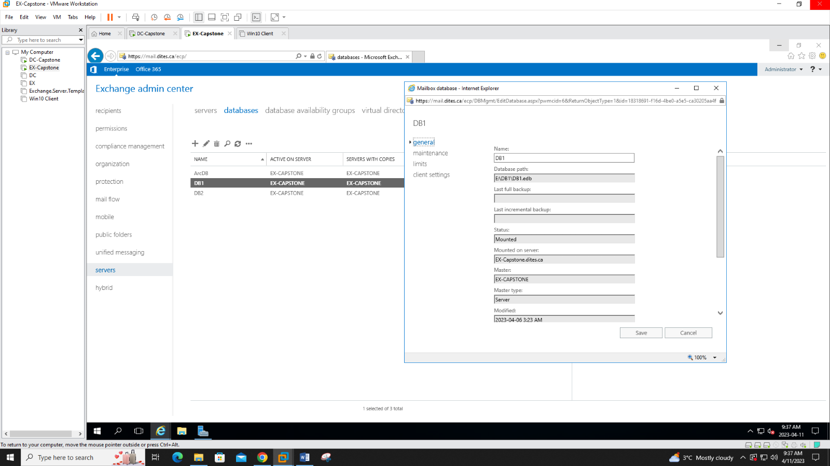

First we created extra databases DB1 and DB2 are on E drive and the ArchDB is on the F Drive

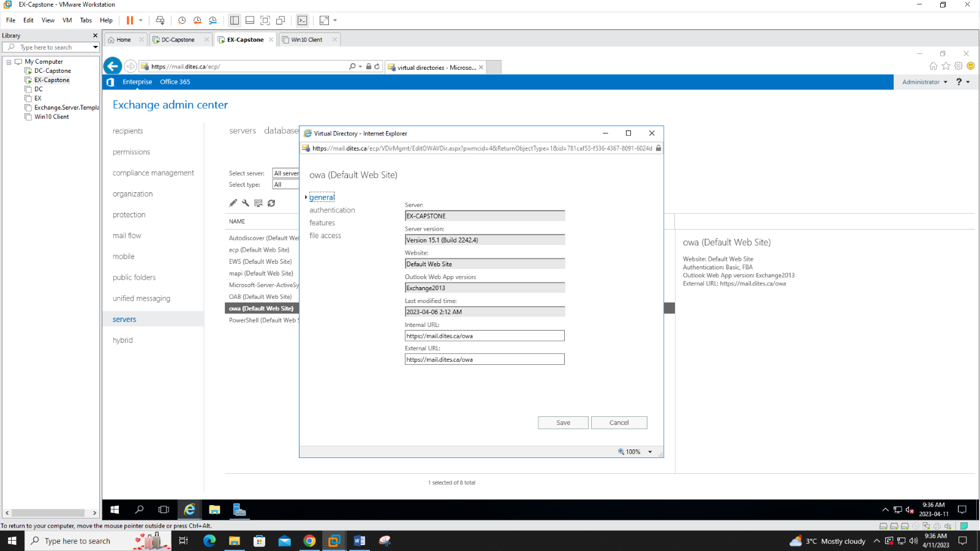

All of the directory links were changed to reflect our domain (I.e. mail.dites.ca)

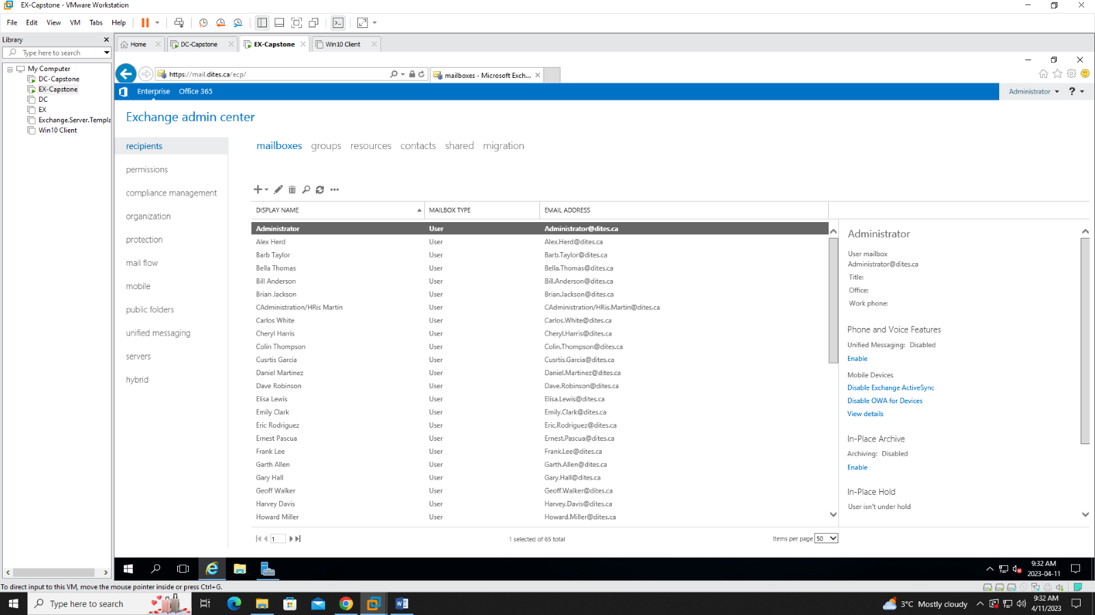

Users were imported through CSV file and sorted into proper OUs then the mailboxes were activated

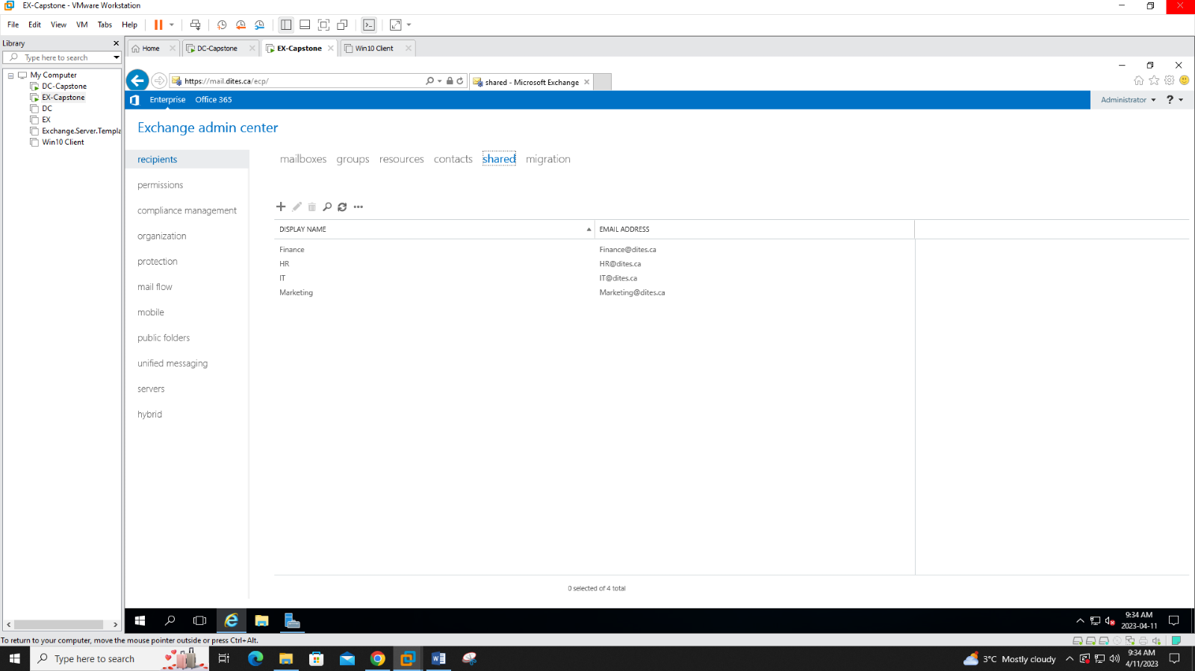

A shared mailbox was created for each department

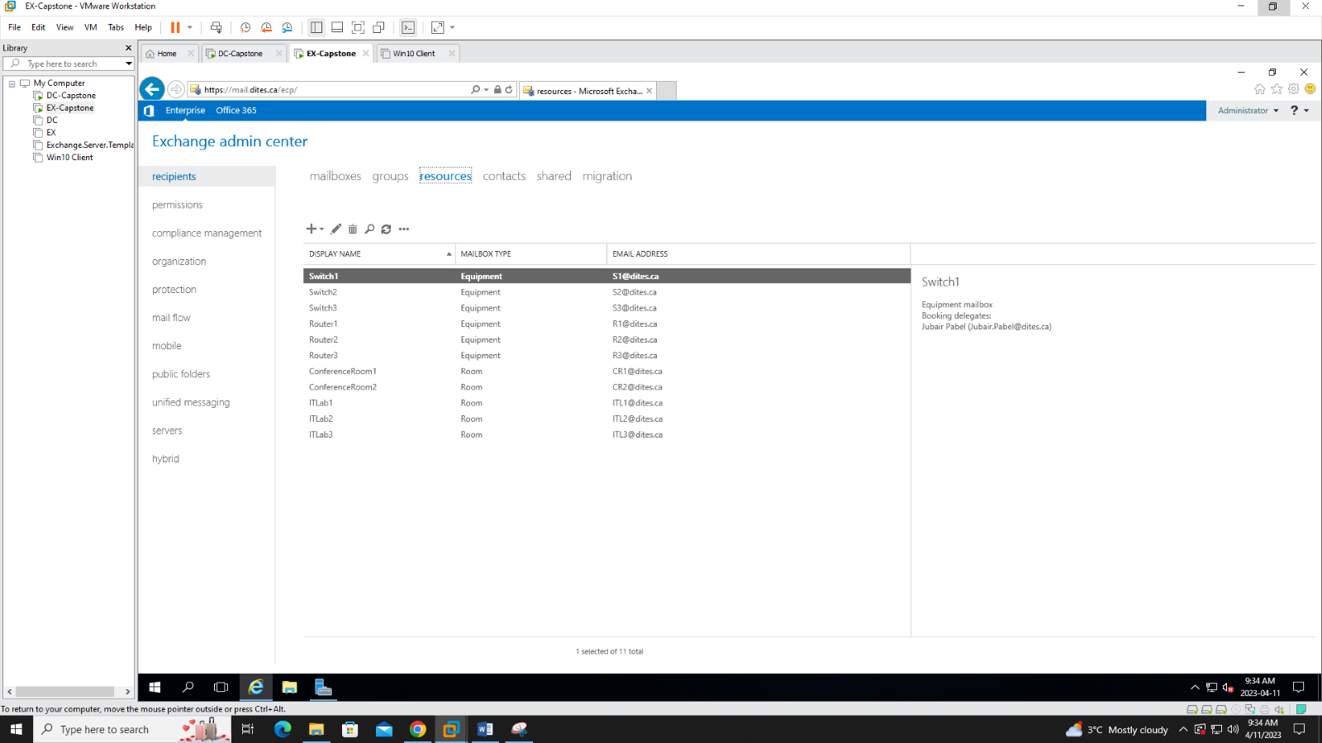

We also created resource mailboxes for the purpose of scheduling Conference rooms and IT labs as well as renting switches and routers for class purposes.

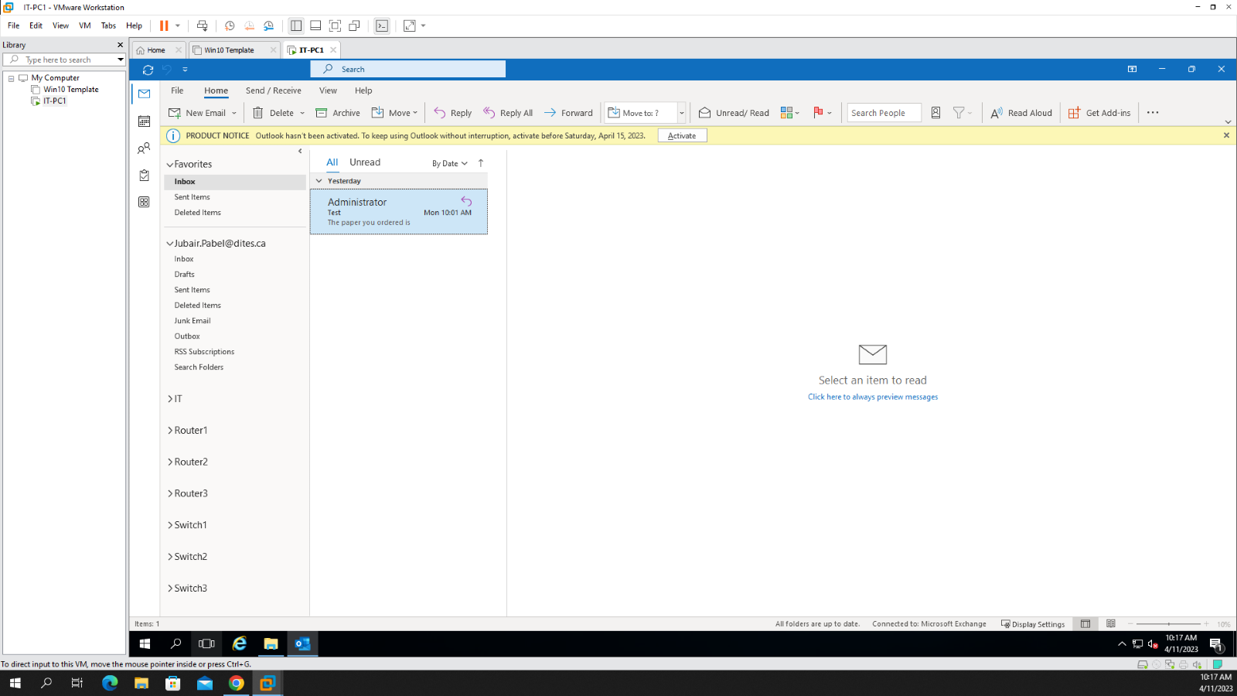

The above screenshot showcases the shared mailbox (IT) and resource mailboxes for equipment rentals in an outlook account for the IT head.

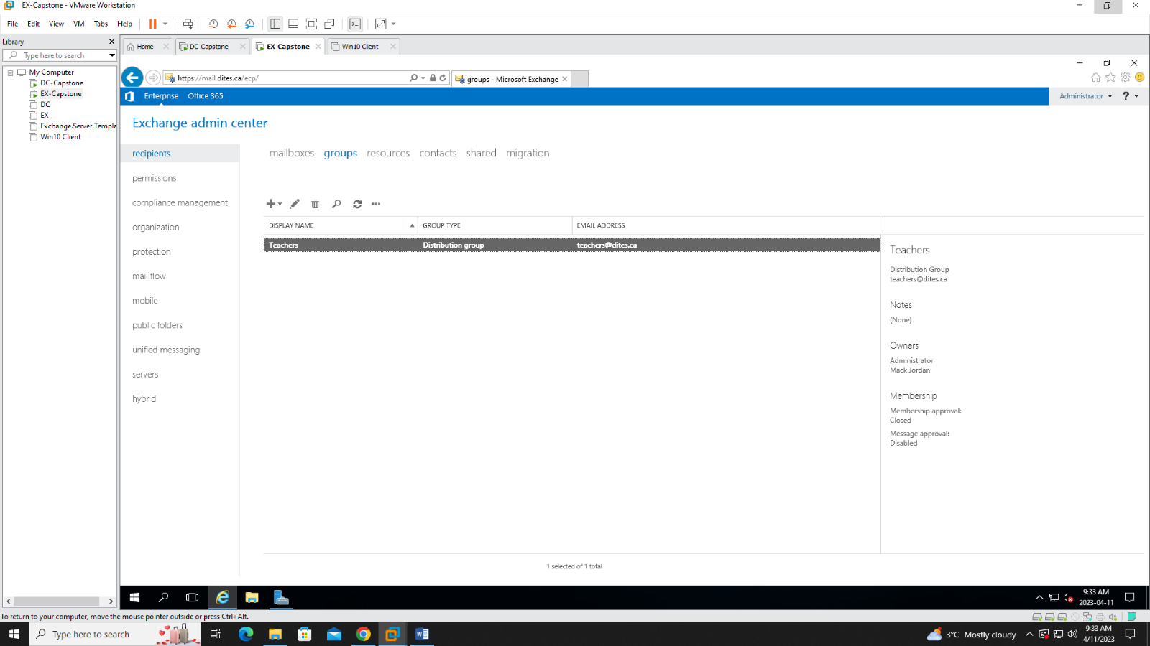A distribution group was created for the teachers.

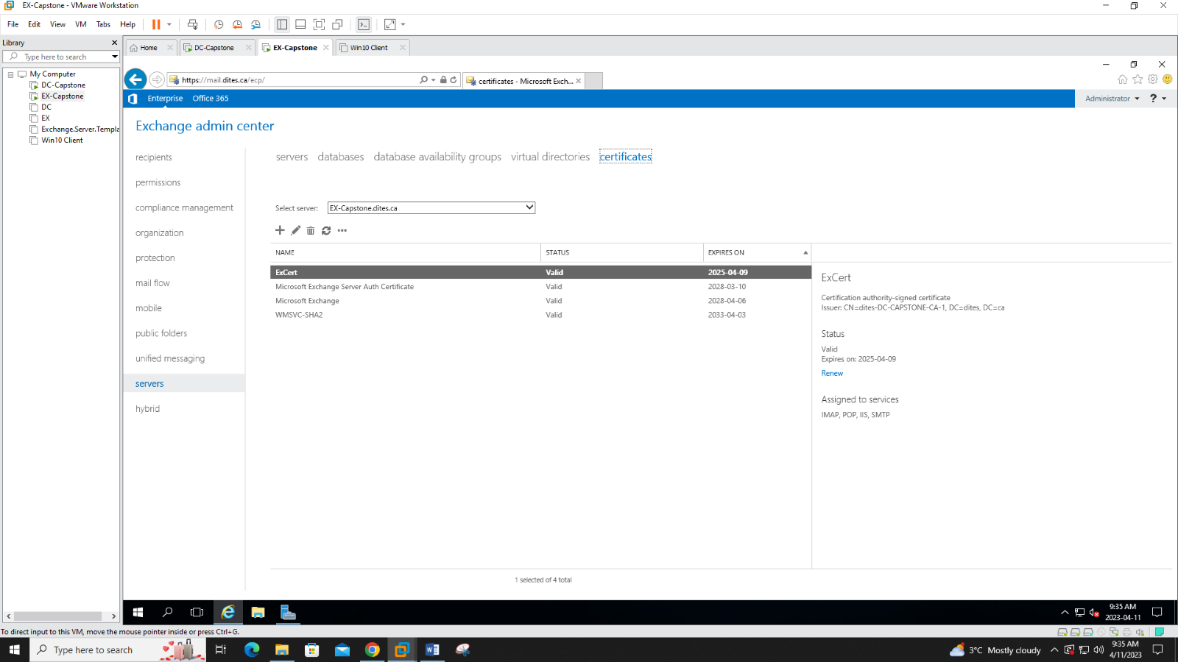Finally we used an internal SSL certificate to validate our Exchange Server.